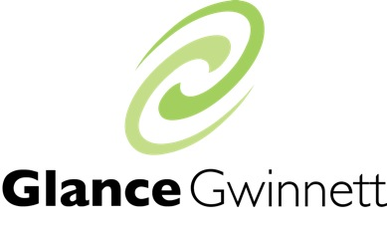

Application for Glance Gwinnett Scholarship

If you are requesting financial assistance to participate in the program, please complete the following questions. While we are able to offer limited financial assistance, the Leadership Gwinnett Foundation does not provide full scholarships. To receive consideration, questions must be answered completely and accurately.

Name ______________________________________
Address ______________________________________
______________________________________
Email ______________________________________
Phone ______________________________________

Who is ultimately responsible for covering your tuition costs?

- My employer will either pay or reimburse me for the entire tuition.
- My employer will either pay or reimburse me for a portion of the tuition
- An organization other than my employer will either pay or reimburse for all or a portion of the tuition
- I am personally responsible for the entire tuition

Are you requesting a scholarship?

- Yes
- No

What other sources are you pursuing for financial assistance?

Please indicate the total amount you are requesting. We do not grant full scholarships, but we would like to enable your participation.

$_________________

What is your reason for requesting a partial scholarship?

What are your major job responsibilities?

How are you currently engaged in the Gwinnett community?

Why would you like to participate in Glance Gwinnett and how will you use this experience to positively impact the community and your organization?

Terms and Conditions

- Tuition is non-refundable. In the event you are unable to complete the Glance program, or are dismissed from the program, you agree to refund 100% of the scholarship funds awarded back to the Leadership Gwinnett Foundation within 30 days.

- For scholarship applicants only -- partial scholarships awarded are an advance and those receiving are asked to pledge at least $50 annually to the Leadership Gwinnett Foundation following graduation so that other worthy applicants can benefit from scholarship dollars.

- Check this box to certify you have read and understand the terms and conditions.

Please return this scholarship application to:

Brooke Waters
Program Manager, Glance Gwinnett
c/o Leadership Gwinnett Foundation
6500 Sugarloaf Parkway
Duluth, GA 30097

OR

bwaters@leadershipgwinnett.com

